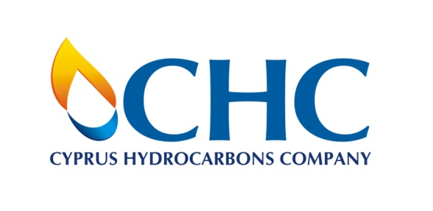
Internship Application Form

- Personal Information
Name
Current Address
Date of Birth
Nationality
Phone No.
Email

- Current Educational Status
Academic Institution
Course Title
Degree Type (BSc, MEng, etc.)

- Please complete the following questions, while ensuring the word limit is not exceeded

- What motivated you to follow your field of study (max 200 words)

- Summarise, in your own words, how the hydrocarbons industry can contibute to future socioeconomic developments (max 300 words)

- Additional Documents
Please also provide the below documents for your application to be considered complete.

- A recent CV
- A transcript of your academic record (including modules completed)
- An academic reference letter

Declaration
I declare that all the information provided by me in this application, and any accompanying documents, is correct, accurate and complete to the best of my knowledge. I understand that false information may be grounds for not offering employment or for termination of employment at any point in the future.
I declare that I have read and accept the conditions set out in CHC’s Privacy Policy (https://chc.com.cy/wp-content/uploads/elenora/2017/03/CHC-Privacy-Policy-clean.pdf) and consent to the processing of my submitted personal data for the purposes of this internship application.

Signature |  |  | Date

